VISHWAKARMA UNIVERSITY
Academic Year: 2025-26 | Semester II
ADVANCED WEB TECHNOLOGY
NAME OF THE STUDENT : | Aaditya Dhanwate
DEPARTMENT : | ARTIFICIAL INTELLIGENCE & DATA SCIENCE
CLASS / DIV. : | TY / A
SRN : | 31230319
ROLL NO. : | 8

ASSIGNMENT NO.: 08
Develop an Angular Service for Data Management and Implement Angular Routing for Seamless Navigation Between Distinct Components
OBJECTIVE:
• Build an Angular SPA (Angular Students App) with Home, Students List, Add Student, and About pages
• Create a centralized StudentService to manage student data across independent components
• Implement Angular Routing via AppRoutingModule and use ngModel two-way binding for form inputs

Problem Statement: Develop an Angular application called 'Angular Students App' with multiple pages (Home, Students List, Add Student, About) and implement Angular Routing for navigation between them. Create an Angular Service (StudentService) to centrally manage student data, and use ngModel two-way data binding for the Add Student form to add and delete student records.
Output:
1. Home Page – Welcome to the Angular Students App
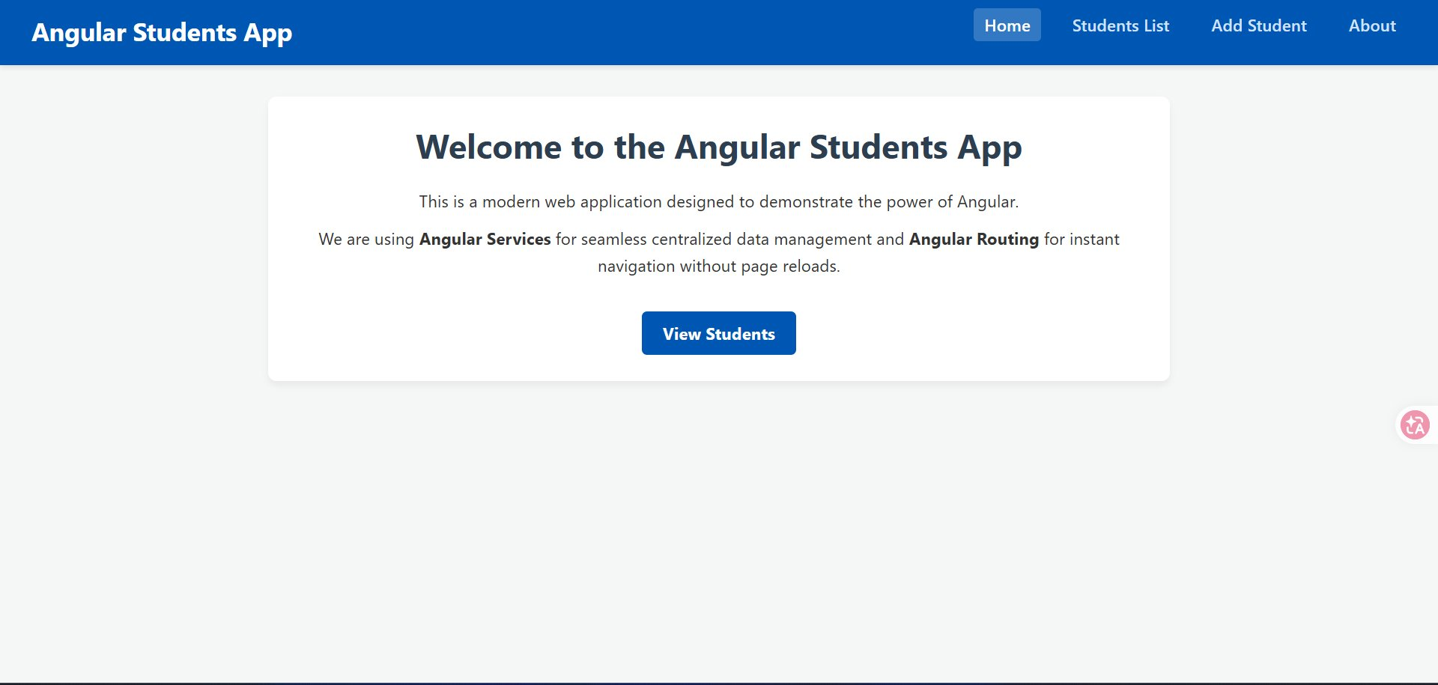
2. Students List Page – Displaying Existing Student (Alice)
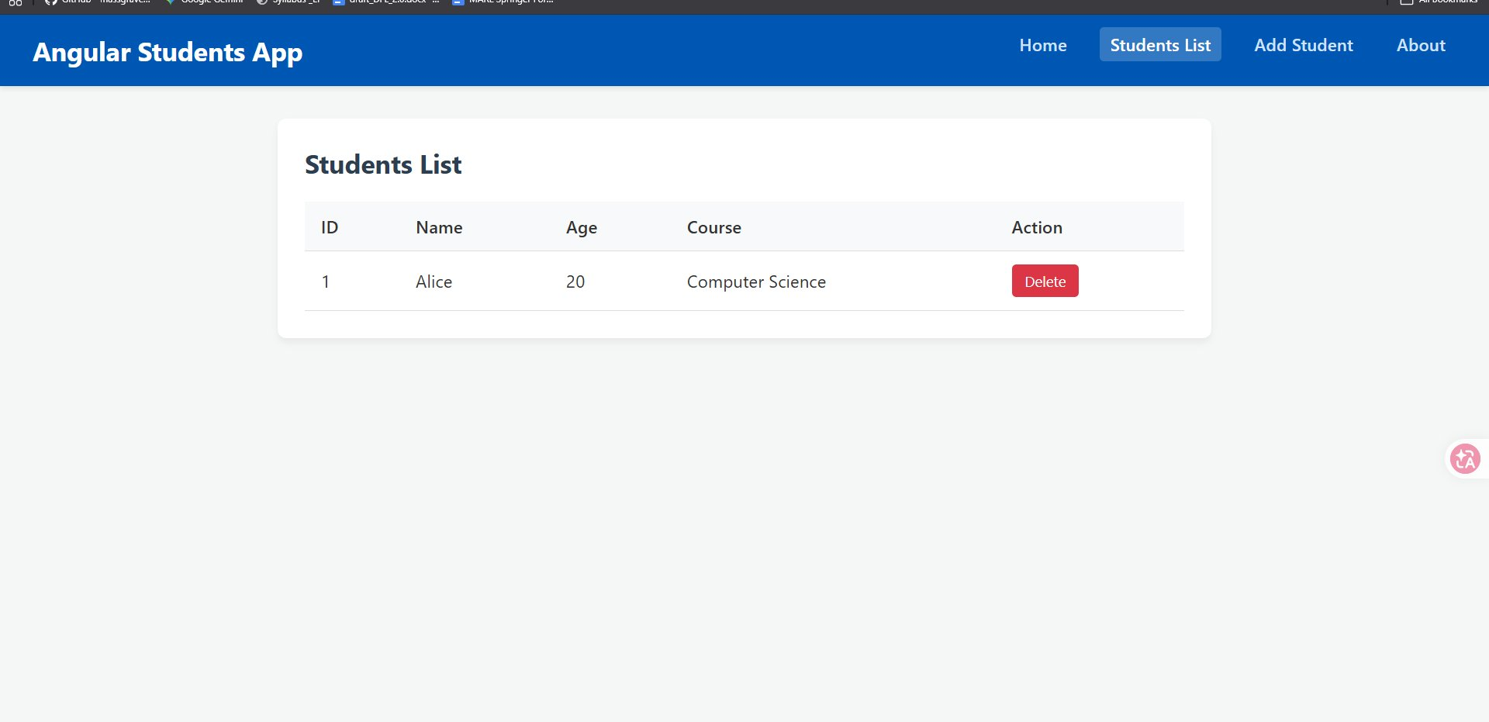
3. Add New Student Page – Form with Name, Age, and Course Fields
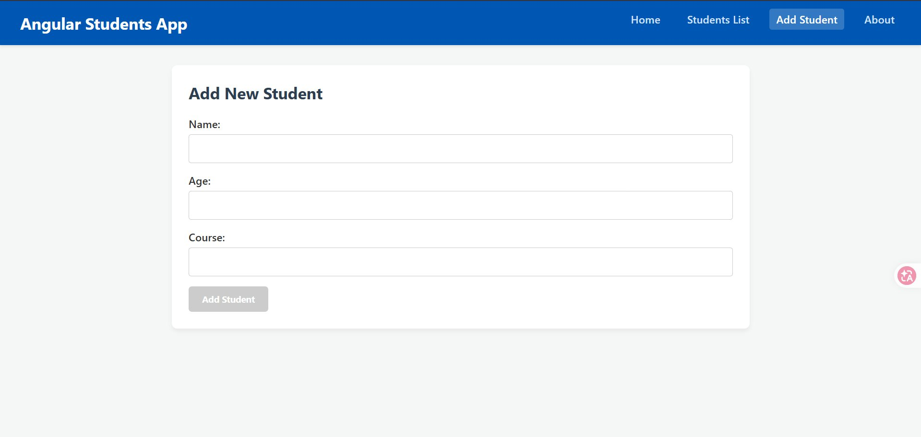
4. About This Application Page
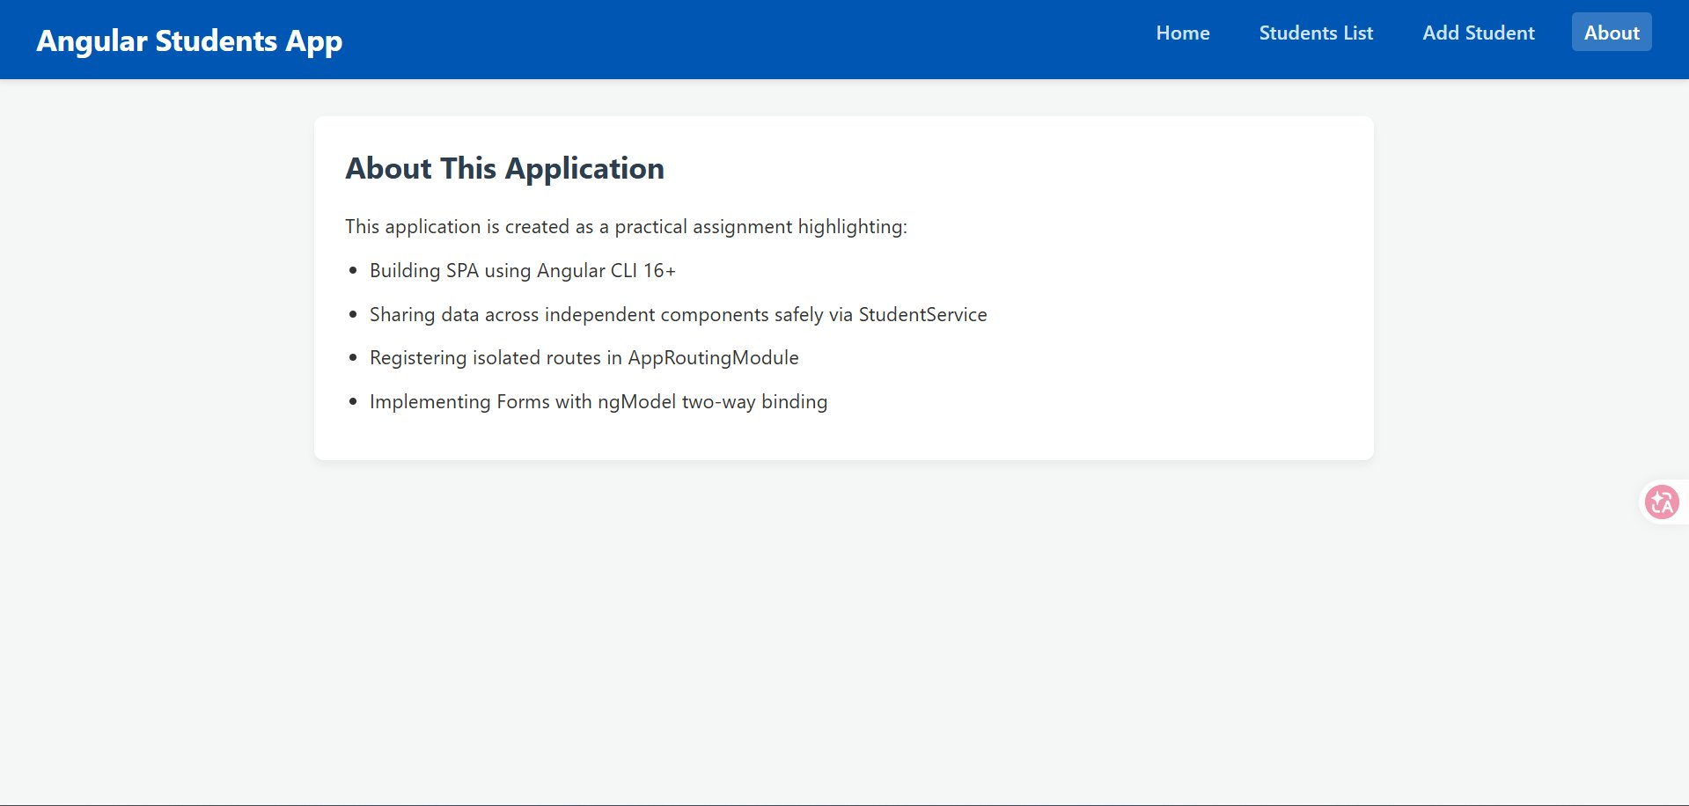
5. Students List After Adding New Student (aaditya dhanwate – ai&ds)
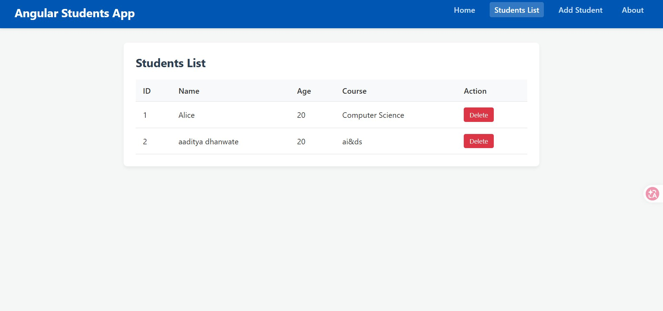

Conclusion:
In this assignment, a fully functional Angular SPA titled 'Angular Students App' was developed using Angular CLI 16+. The application features four navigable pages — Home, Students List, Add Student, and About — with seamless routing via AppRoutingModule. A centralized StudentService manages shared student data across components, and the Add Student form uses ngModel two-way data binding to dynamically add students to the list. The Delete functionality allows students to be removed in real time.

